

a application

Security Assessment Findings Report

Project: a application

Date: 2024-11-11

Reporter: John Doe

**Table of Contents**

# Executive Summary

executive_summary

# Technical Summary

|  |  |  |  |  |  |
| --- | --- | --- | --- | --- | --- |
| **Findings** | | | | | |
| **Critical** | **High** | **Medium** | **Low** | **Informational** | **Total** |
| 0 | 1 | 0 | 0 | 0 | 1 |

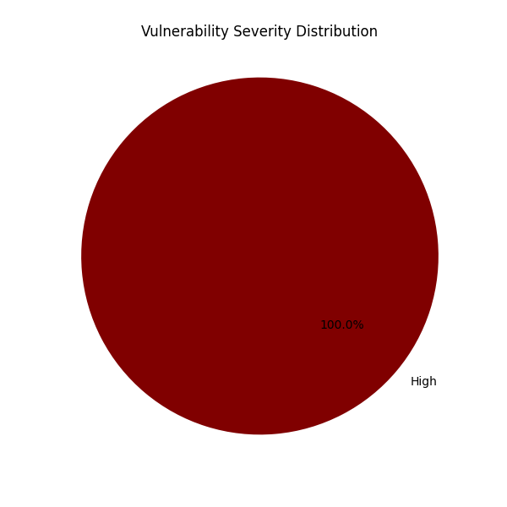

# Vulnerabilities

## 1. XSS

**Severity: High**

**URL/Vulnerable component:** http://example.com/comment

**Description:** Cross-Site Scripting

**Impact:** Account takeover

**Remediation:** Sanitization

**PoC:** {{7*7}}